
The In Touch
Volume 59, Issue 7
Our Mission: To Seek, Know, Love and Serve Christ in all Persons and in all Creation
Ramblings from the Deacon……
As most of you know I am living with terminal cancer. I don't think of myself of dying from it. Not yet. Rather, we're co-existing for now.
One of my worries was what would happen if I fell at church and broke a bone and let out a sting of words that I wouldn't want anyone to remember me by. But, as it turns out when I did break a bone my first thought was a calm 'Well, this isn't good.' The swearing did come later when they moved me. Every time they moved me.
I fell at a friend's house while taking care of their animals while she was with her husband who was in the hospital in Duluth. The ambulance had been called for him at the same house and the crew was happy to hear that he was doing well. I realized that as hard as they work they don't always know the results of their efforts. The same with the ER staff when they send a patient off. So, that was one good thing.
They cut my clothes off and I didn't even wonder if I had my newest, best underwear on. One more good thing.
When I got home, I realized that I have experienced in real life two of the worst commercials – but for really useful products -ever made. “I've fallen and I can't get up!” And “clap on, clap off, the clapper” when I couldn't reach the switch on the lamp. And, that was one funny thing.
Typically I have a day or two in the week following chemo where I really don't feel well. It's not horrible, rather tired with a nagging annoying upset stomach so I rest a lot. And feel sorry for myself at times. I thought at first that I should be using that time to talk to God, but stray thoughts seem to run through my head and the talking to and receiving answers from God come as I begin to feel better. That was one benefit of stillness.
I realized weeks after the fracture that the timing was perfect. There were things I needed to experience that I wouldn't have if I had been able bodied. I learned to ask for help. I asked God what I could learn from this and learned that I was wrong about some of the things I thought other people were going through. That one stung, but is one thing I'm so grateful for.
I learned that it's okay to be tired, to miss a meeting, or even church. It's one of the things I wish I had learned sooner.
Kelly, Emma, Tyler and Milo are staying with me. And Brandon when he's home. Plus, six cats, three dogs, guppies, seven chickens, one goose, one rabbit, and two horses. We're making memories while my little house is bursting at the seams. It is a joyful and sometimes frustrating chaos. Shane and Jenny are helping her folks with her dad's dementia and her mom's broken leg. Family is family when we can be together and when we can't. Love is there.

I don't believe that my cancer was preordained. I don't think we're born with a set expiration date. I do know without a doubt that God is with me. That he's helping me with the last lesson I have to share with my family. That I couldn't do this with grace without him. And, having his love is the best thing.

Peace,
Mel Mattsen
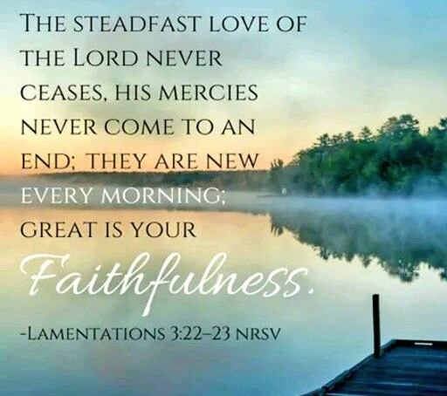

Watch Holy Trinity Livestream On Facebook
Service bulletin is on our website: www.ifhtec.org
Sundays @ 10:00 am
Services can also be viewed on KCC-TV

  7/1~7/31 ~ Ryan Krieger  ~ Stephanie Fort  ~ MaryAnn Tveit  ~ Logan Krieger  ~ Sheila Shoquist  ~ Carol Grim  ~ Dean Tveit  ~ Madalynn Jenkinson  ~ JoAnne Harvey  ~ Lee Grim  ~ Melanie Mattsen  ~ Rick Windschitl |   7/8 ~ Jan Menefee  7/10 ~ Connor Weir  7/13 ~ Emma Mattsen  7/20 ~ Caryn Noland  7/27 ~ Sara O’Kane  7/27 ~ Tessa Walls    7/20 ~ Mike & Tricia Brennard  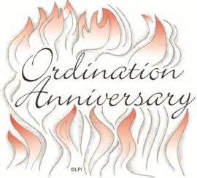  7/8 Rev. Lynn Naeckel

Voyageurs Park Service Dates Will Be:
July 21st, Aug. 4th & 18th
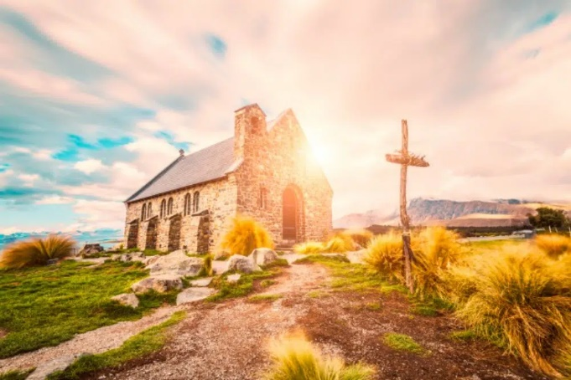
As you pass this little church,
be sure you pay a visit,
So when at last you are carried in,
God won’t ask “Who is it?”
Author unknown,
I remember Art Corrin sharing this saying…

“When you enter this church it may be possible that you hear
“The Call of God” however,
It is unlikely that He will call you on your mobile/cell.
Thank you for turning off your phones.
If you want to talk to God,
enter, choose a quiet place and talk to Him.
If you want to see Him in person,
Send Him a text while driving.”
Poster in a Church in France

July ‘24 Sunday Service Lay Responsibilities
Dates | Celebrants | Acolytes | Lectors & Lessons | Greeters
7  Holy Eucharist  10:00 am  7th Sunday after Pentecost | Rev. Dr. Samantha Crossley  Deacons: Lee Grim or  Melanie Mattsen | Lee Grim  Or  Melanie Mattsen | Carole Johnson
14  Holy Eucharist  10:00 am  8th Sunday after Pentecost | Rev. Dr. Samantha Crossley  Deacons: Lee Grim or  Melanie Mattsen | Lee Grim  Or  Melanie Mattsen | Molly Pavleck
  21  Holy Eucharist  10:00 am  9th Sunday after Pentecost | Rev. Dr. Samantha Crossley  Deacons: Lee Grim or  Melanie Mattsen | Lee Grim  Or  Melanie Mattsen | Jeanne Corrin
28  Holy Eucharist  10:00 am  10th Sunday after Pentecost | Rev. Dr. Samantha Crossley  Deacons: Lee Grim or  Melanie Mattsen | Lee Grim  Or  Melanie Mattsen | Erik Strand
 JULY 2024
Sunday | Monday | Tuesday | Wednesday | Thursday | Friday | Saturday
 | 1 | 2 | 3 | 4 | 5 | 6 Altar Guild
 |  |  |  |  |  | Donna & Karen
7 | 8 | 9 | 10 | 11 | 12 | 13 Altar Guild
Holy Eucharist  10:00 a.m. |  |  |  |  |  | Donna & Karen
14 | 15 | 16 | 17 | 18 | 19 | 20 Altar Guild
Holy Eucharist  10:00a.m. | Vestry  5:00 pm  Ruby’s Pantry  5:00 – 6:30 |  |  |  |  | Georgeann & Michele
21 | 22 | 23 | 24 | 25 | 26 | 27 Altar Guild
Holy Eucharist  10:00 a.m. | Newsletter Deadline  ( ? ) |  |  |  |  | Georgeann & Michele
28 | 29 | 30 | 31
Holy Eucharist 10:00 a.m.

